FSU – Spring 2 (Year A) Newsletter

Topic: ***Living Things***

**Key Information**

**FSU staffing**

|  |  |  |  |  |
| --- | --- | --- | --- | --- |
| **Monday** | **Tuesday** | **Wednesday** | **Thursday** | **Friday** |
| Mrs Clarke  Mrs Ling | Mrs Clarke  Mrs Ling | Mrs Clarke  Mrs Ling | Mrs Clarke  Mrs Ling | Mrs Wells  Mrs Ling |
| Mrs Clarke  Mrs Ling | Mrs Ling  Miss Buckley | Mrs Clarke  Mrs Ling | Mrs Clarke  Miss Buckley | Mrs Wells  Mrs Walters |

**Our class is growing-we welcome another new nursery child this term!**

**Homework** –All Reception children should complete a piece of homework from the homework grid each week and upload it weekly onto the *Tapestry App*.

They should alsoread one of their ‘Red Ditty’ stories or the corresponding *Book Bag* book story, to you each day (min.5 times a week); and practise the red words on their bookmarks.

**Nursery sharing books** are changed once a week. These stories should be read TO your child to develop their idea of how books work, their imagination and extend their vocabulary.

**PE** We have *Jumping Jacks* leading a Gymnastic session on Tuesday mornings and *Early Years Activators* coming in on Wednesday mornings. Please make sure all children attending those sessions have a full NAMED Charlton PE kit in school. (White T Shirt (a change from school uniform), navy shorts, long navy joggers or leggings AND a plain navy hoodie or sweatshirt. (NO LOGOs).Plus a change of socks( especially if your child is likely to be wearing tights) and trainers.)

We do NOT have **Forest School** this term.

**Literacy**

We will be using stories such as Dear Zoo, and The Very Hungry Caterpillar, Titch and Jasper’s Beanstalk to explore our Living Things theme (including Lifecycles). We will also introduce our Core Nursery Rhymes that we want all children to know well by the time they leave FSU. These are:Hey Diddle, Diddle, Humpty Dumpty, Little Bo Peep and Baa, Baa Black Sheep. Finally we will talk about the difference between story and information books when we research Spring using non-fiction texts.

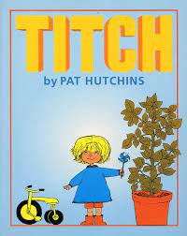 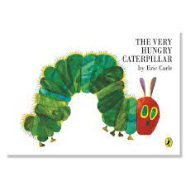 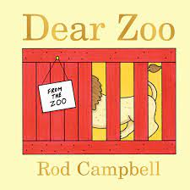

**Phonics**

Reception Children will be learning to read and write the next Set 2 Sounds: **oo**

“Look at a book”, **ar** “Start the car”, **or** “Shut the door”, **air** “that’s not fair”, **ir** “Whirl and twirl” and **ou** “Shout it out”.

Nursery Children will be focusing on the children listening well, especially for rhyming words, those that start with the same letter and different voice sounds.

**Maths**

Reception Children will be looking at the composition of numbers to 10, including pairs of numbers that add together to make 5 and then 10; recognising up to 5 objects without counting them (Subitising); and counting forwards and backwards to 10, knowing which number is one more/one less from any point.

Nursery Children will be making repeating patterns; recognising how many objects there are up to 3 , without counting them (Subitising); and describing routes and locations using positional language e.g. Behind, in front of…

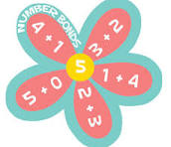 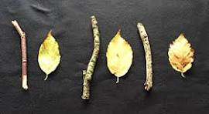

**Understanding the World**

We will be exploring the life cycle of frogs and sheep. Looking for mini beasts and signs of Spring. We will also be planting bean seeds and bringing them home to grow!

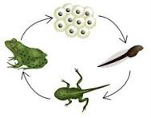

**RE**

The children will hear some more bible stories about Jesus and his life and miracles, Before celebrating mothers and Easter.



**Expressive Arts and Design**

In music we will be learning about some different instruments, how they sound and how they are played. Including, the violin, recorder, accordion and orchestral instruments through watching a telling of Peter and The Wolf. If you play an instrument you would be willing to bring in and demonstrate for the children let us know!

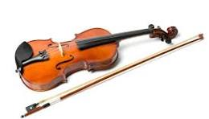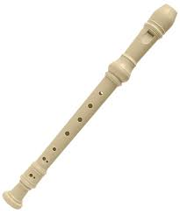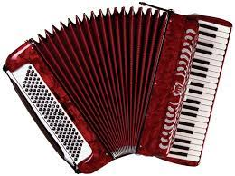

**PSHE**

In PSHE this half term, children will be introduced to the school value of **Forgiveness**.